PES UNIVERSITY EC CAMPUS, BANGALORE

Name: Venkata Krishnarjun Vuppala

SRN: PES2UG19CS451

WEEK: 8

SUBJECT: Computer Network Laboratory

OBJECTIVE: Understand the building blocks and usage of ClayNet Network Virtualization platform with reference to OSI Layer.

## IPv4 Addressing and Topology Creation

* + The following topology is created and deployed on **ClayNet**.

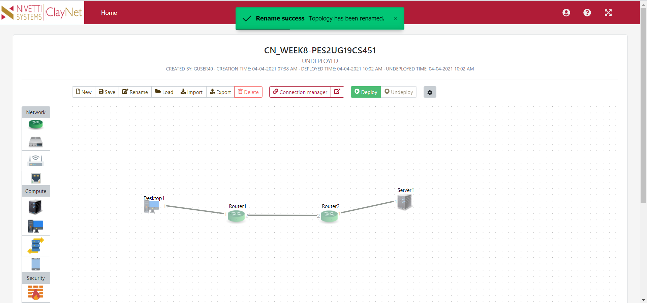

* + The configuration of all the end-system devices is shown below.

|  |  |  |
| --- | --- | --- |
| **End System** | **IP Address** | **Gateway** |
| Desktop1 | 10.10.10.2/24 | 10.10.10.1 |
| Server1 | 30.30.30.2/24 | 30.30.30.1 |

* + Similarly, the routers are configured in the same manner.

|  |  |  |
| --- | --- | --- |
| **Router** | **Interface Number (port)** | **IP Address** |
| Router1 | 1 | 10.10.10.1/24 |
| Router1 | 2 | 20.20.20.1/24 |
| Router2 | 1 | 30.30.30.1/24 |
| Router2 | 2 | 20.20.20.2/24 |

## Ping Command

* + From Desktop1, a **ping** command is made to Server1.
  + However, this ping command fails because the routing table entries have not been configured yet for Router1 and Router2.
  + We obtain a **Destination Host Unreachable** status.

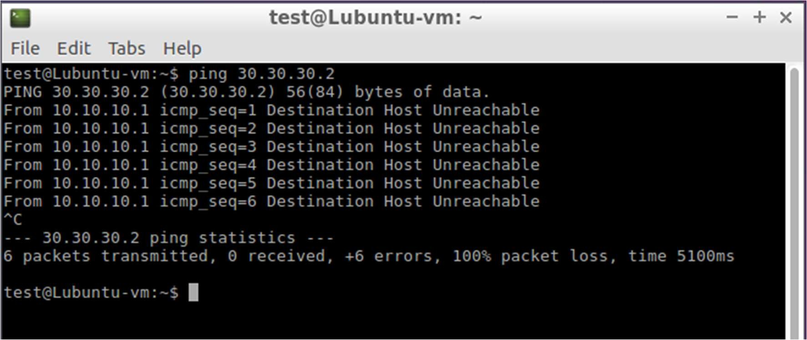

## Configuration of Routing Table Entries

### Router 1

* + - The Routing Table entries for Router 1 are configured using the below commands in the console window.
    - The resulting Routing Table Entry is shown below.

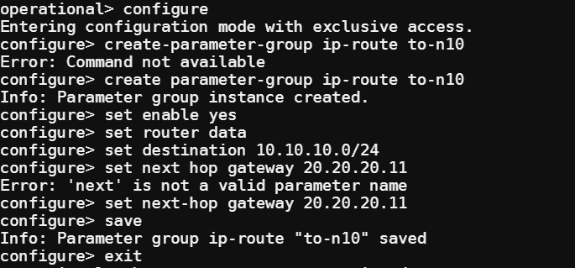

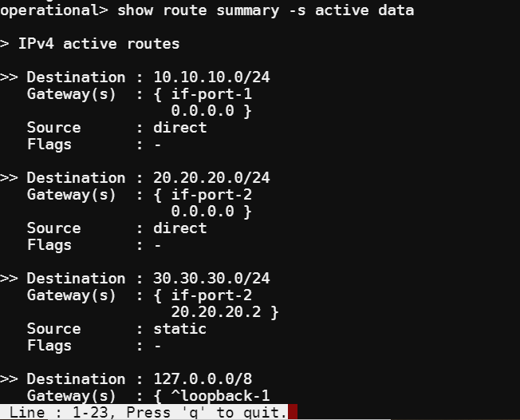

### Router 2

* + - The Routing Table entries for Router 2 are configured using the below commands in the console window.

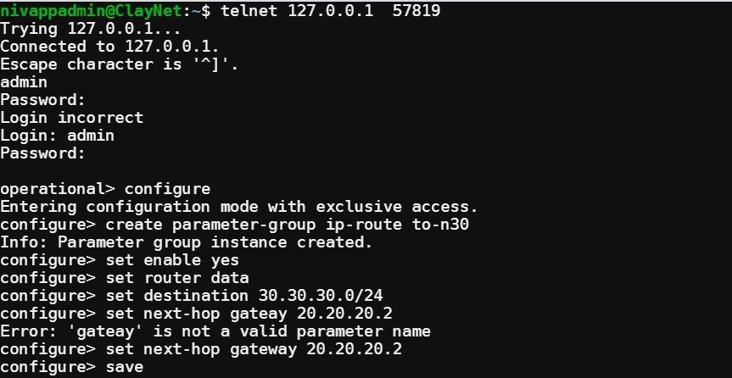

* + - The resulting Routing Table Entry is shown below.

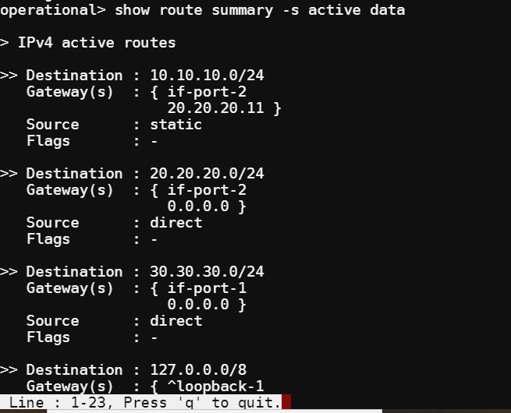

## Observations

* + Desktop1 and Server1 are now reachable from each other.
  + To verify this, the **ping** command is again used to ICMP request packets to the other.
  + Since there are 2 hops between the systems, the TTL value is decremented by 2. Hence the value is decremented from its default value of 64 to 62.

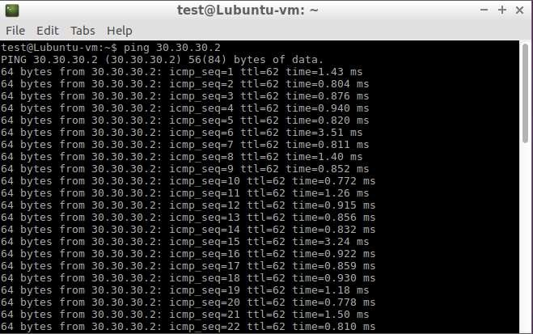

* + - The following Wireshark Packet Capture shows ICMP request packets being sent from Desktop1 to Server1.

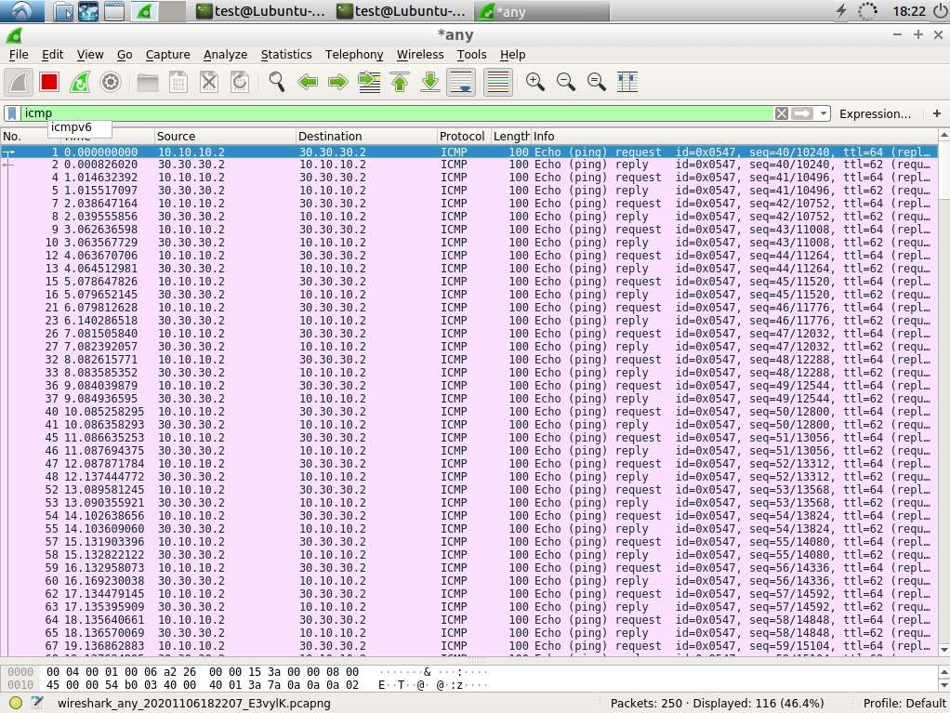

* + - The following screenshot displays the outcome of the traceroute command from Desktop1 to Server1.

